**ShuatsBlog**

Submitted in Partial Fulfilment of the Requirement

for the Award of the Degree of

**B.Tech Computer Science Engineering**

IN

**DISCIPLINE**

BY

**Tanmay Singh**

**(ID. No :20BTCSE021)**

**UNDER THE SUPERVISION OF**

**Dr. Tulika**



**DEPARTMENT OF COMPUTER SCIENCE AND IT**

**VAUGH INSTITUTE OF AGRICULTURAL ENGINEERING AND TECHNOLOGY**

**SAM HIGGINBOTTOM UNIVERSITY OF AGRICULTURE, TECHNOLOGY AND SCIENCES**

**NAINI, PRAYAGRAJ-211007**

**2023**

**DECLARATION**

I, Tanmay Singh declare that the work presented in this project report entitled **ShuatsBlog** submitted to the **Dr. Tulika** Department of Computer Science and Information Technology in Faculty of Engineering and Technology, **Sam Higginbottom University of Agriculture, Technology and Sciences, Naini, Prayagraj** for the award of the B.Tech in Computer Science and Engineering is an original work. I have neither plagiarized nor submitted the same work for the award of any other degree. In case this undertaking is found incorrect, my degree may be withdrawn unconditionally by the University.

Date: Signature of Student

Place: Tanmay Singh

(ID. No. 20BTCSE021)

**CERTIFICATE**

Certified that the project report entitled “**ShuatsBlog”** submitted to **Sam Higginbottom University of Agriculture, Technology and Sciences, Deemed University, Naini, Prayagraj** in partial fulfilment of the requirement for the degree of B.Tech in Computer Science and Engineering **Faculty of Engineering and Technology** is a bonafide record of project report carried out by **Tanmay Singh (20BTCSE021)** under my supervision and guidance.

Date: Signature

Place: Dr. Tulika

Assistant professor

**CERTIFICATE OF ACCEPTANCE OF EVALUATION COMMITTEE**

This is to certify that project entitled “ShausBlog” has been prepared and submitted by Tanmay Singh in partial fulfillment of the requirement for the award of the degree of “Bachelor of Technology in Computer Science & Engineering” in Department of Computer Science and Information Technology, Vaugh Institute of Agricultural Engineering and Technology, Sam Higginbottom University of Agriculture, Technology and Sciences, Prayagraj (U.P.) INDIA.

Name Evaluation Signature

**Dr. Tulika Satisfactory /**

**Project Coordinator**

**Assistant Professor Unsatisfactory**

Department of Computer

Science & IT SHUATS,

Prayagraj

**Er R. Dileep Kumar Satisfactory /**

**Project Coordinator**

**Assistant Professor Unsatisfactory**

Department of Computer

Science & IT SHUATS,

Prayagraj

**Er Rishabh Choudhary Satisfactory /**

**Project Coordinator**

**Assistant Professor Unsatisfactory**

Department of Computer

Science & IT SHUATS,

Prayagraj

**Satisfactory /**

**Dr. Tulika Unsatisfactory**

**Project Advisor**

Department of Computer

Science & IT SHUATS,

Prayagraj

The evaluation committee has thoroughly examined this project and has found it acceptable.

Dr. W. Jeberson (Chairman HoD, Department of Computer Science and IT SHUATS, Prayagraj)

**ABSTRACT**

The "ShuatsBlog" web project is an innovative and dynamic online platform designed to empower users to express their creativity, passions, and stories through a unique fusion of visual and written content. In a digital era where self-expression knows no bounds, this project introduces a novel approach to blogging that combines the art of collage-making with the power of digital media. Users can create captivating and thematic narratives by curating a diverse range of images, artwork, photographs, and multimedia content, coupled with insightful commentary. The future scope of the project includes the development of mobile applications, enhanced interactivity, revenue-generating options, improved recommendation algorithms, accessibility enhancements, and internationalization efforts. By embracing ongoing innovation and user feedback, the "Collage Blogging" web project aspires to continue growing, adapting, and providing a vibrant platform for creative expression and community interaction.

**TABLE OF CONTENTS**

**Title Page No.**

DECLARATION

CERTIFICATE

CERTIFCATE OF ACCEPTANCE OF EVALUATION COMMITTEE

ABSTRACT i

ACKNOWLEDGEMENT ii

TABLE OF CONTENTS iii

LIST OF TABLES iv

LIST OF FIGURES v

**CHAPTER I INTRODUCTION** 1

**CHAPTER II REQUIREMENT SPECIFICATION**  5

**CHAPTER III SYSTEM DESIGN** 9

**CHAPTER IV IMPLEMENTATION AND TESTING** 13

**CHAPTER V CONCLUSION** **AND FUTURE SCOPE** 17

**REFERENCES** 20

**APPENDICES**

**Appendix A Sample Code 22**

**Appendix B Screen Shots** 24

**INTRODUCTION**

In today's digital age, creative expression knows no bounds, and the world of blogging has opened up new avenues for individuals to share their thoughts, passions, and stories with the world. While traditional blogging has long been a popular medium, a new form of self-expression is emerging, and it's taking the online world by storm: Collage Blogging.

Collage Blogging is an innovative and visually captivating way for bloggers to tell their stories, share their interests, and communicate their ideas. It combines the art of collage-making with the power of digital platforms, offering an exciting and dynamic medium for creators to showcase their content.

**The Future of Collage Blogging Website :**

Collage Blogging is a growing trend, and it's here to stay. As digital tools and platforms continue to evolve, Collage Blogging is becoming more accessible and user-friendly, making it a medium that appeals to both seasoned bloggers and newcomers alike. Its visual appeal and creativity are perfect for the social media age, where content needs to stand out and engage viewers.

In this blogosphere, where words and images come together in a symphony of creativity, Collage Blogging is your canvas, and the internet is your audience. It's a space for self-expression, storytelling, and exploration. So, if you're looking for a new way to share your passion with the world, consider joining the Collage Blogging revolution – where your creativity knows no boundaries.

**Technologies used are:**

**Java** (Server side)

Java is a versatile and widely used programming language that can be applied in various aspects of a website, including the backend, middleware, and even the frontend. In the context of a collage blogging website, Java can be utilized as follows:

1. Backend Development: Java can be used to develop the backend of the website, which includes handling user authentication, managing content, and ensuring data security. Java frameworks like Spring and Java EE can be employed to create robust and scalable server-side applications. The backend can handle user registration, authentication, and the storage of user-generated content.
2. User Authentication: Java can facilitate user authentication and authorization processes to secure user data and restrict access to certain website features. Technologies like Java Web Tokens (JWT) can be used to manage user sessions securely.
3. Data Processing: Java can be used for data processing tasks, such as resizing and optimizing images, handling file uploads, and managing user-generated content efficiently.
4. APIs and Integrations: Java can be used to create APIs for interaction with other services or social media platforms, allowing bloggers to seamlessly integrate external content into their collage posts.

**MySQL**(Database)

MySQL is an open-source relational database management system commonly used in web applications. In a collage blogging website, MySQL serves as the backend database, handling data storage and retrieval. Here's how MySQL can be used:

1. Content Management: MySQL can store all the essential data for the website, such as user profiles, blog posts, images, comments, and more. It provides a structured way to organize and manage content.
2. User Data: User information, such as usernames, email addresses, and hashed passwords, is securely stored in the MySQL database. This information is used for user registration, login, and personalization of the user experience.
3. Blog Post Storage: Blog posts, including text content, images, and metadata, are stored in the database. MySQL enables efficient retrieval and display of blog posts, making it possible for users to view and interact with collage content.
4. Relationships and Associations: MySQL can manage relationships between various entities, such as associating blog posts with their respective authors, comments with posts, and tags with content.
5. Data Integrity: MySQL ensures data integrity and consistency, which is crucial in maintaining the quality and reliability of the website's data.
6. Performance Optimization: Database queries and indexing can be optimized to ensure fast retrieval of content, enhancing the user experience.

In summary, Java and MySQL play essential roles in a collage blogging website. Java is primarily used for backend development, user authentication, and data processing, while MySQL is used as the backend database for content storage, user management, and data retrieval. Together, these technologies provide a solid foundation for creating a dynamic and user-friendly collage blogging platform.

**JavaServer Pages** (Front End)

The front end of your collage blogging website is a viable option, although it's important to note that modern web development often incorporates more client-side technologies like HTML, CSS, and JavaScript for a dynamic and responsive user interface. Nevertheless, JSP can still be part of the front-end stack, especially for rendering dynamic content and integrating with your Java backend. Here's how JSP can be used in your website's front end:

**Dynamic Content Rendering:** JSP allows you to embed Java code within your web pages, enabling you to dynamically generate HTML content. This is useful for rendering blog posts, user profiles, comments, and other user-generated content.

**Templates and Layouts:** You can create reusable JSP templates and layout files that define the structure and look of your website. These templates can be used to maintain a consistent design throughout your website.

**User Profile Pages:** JSP can be used to display user profiles, including user information, profile pictures, and lists of their blog posts.

**Blog Post Display:** JSP can generate dynamic blog post pages, showing the collage content, associated metadata, and comments. It can also handle features like liking, sharing, and bookmarking posts.

It's essential to remember that while JSP can be a valuable tool for server-side rendering, a modern web application often benefits from a combination of technologies. Using HTML, CSS, and JavaScript (along with frameworks like React or Angular) on the client side can enhance user interactivity, responsiveness, and the overall user experience. You can use JSP to generate dynamic content from the server while leveraging client-side technologies for a richer front-end experience. This approach combines the strengths of both server-side and client-side development.

**REQUIREMENT SPECIFICATION**

To create a collage blogging website using technologies like Java, MySQL, and JSP, you'll need to consider several key requirements to ensure the website's functionality, security, and user experience. Here are the essential requirements for your collage blogging website:

**User Registration and Authentication:**

User registration with email verification.

Secure user authentication and password management.

User profile pages with editable information and profile pictures.

**Content Creation and Management:**

Ability for users to create, edit, and delete collage blog posts.

Uploading and management of images and multimedia content.

Categorization of posts, such as tagging and topic selection.

**Social Features:**

Social media sharing and integration for posts.

Commenting on blog posts.

Following and interacting with other users.

**Search and Navigation:**

User-friendly search functionality to discover content.

Filters and categories for exploring different topics.

Navigation menus and content recommendations.

**Content Display:**

Dynamic rendering of blog posts with JSP.

Integration with the MySQL database for data retrieval.

Optimization for the display of images and multimedia content.

**User Interactions:**

Like, bookmark, and share functionality for blog posts.

Reporting system for inappropriate or offensive content.

**Admin and Moderation:**

Admin dashboard for managing users and content.

Moderation tools to review reported content.

**Email Notifications:**

Send email notifications for account-related activities, such as password resets and new follower alerts.

**Responsive Design:**

Ensure a responsive and mobile-friendly design for various devices.

**Security:**

Protection against common web application security threats (e.g., SQL injection, cross-site scripting).

Data encryption and secure user authentication.

**Performance Optimization:**

Optimize website performance for fast loading times.

Efficient use of server resources to handle traffic spikes.

**Content Management System (CMS):**

Provide bloggers with a user-friendly CMS for creating and managing their content.

**Backup and Recovery:**

Implement regular data backups and a recovery plan in case of data loss.

**Compliance and Legal Considerations:**

Ensure compliance with data protection regulations and copyright laws.

**Scalability:**

Plan for scalability to handle a growing user base and content volume.

**Analytics and Reporting:**

Incorporate analytics tools to track user engagement, traffic, and popular content.

**Testing and Quality Assurance:**

Perform thorough testing, including functional, security, and performance testing.

**Documentation:**

Create comprehensive documentation for developers and administrators.

**Hosting and Server Infrastructure:**

Choose a reliable hosting solution to deploy your website.

**SYSTEM DESIGN**

The system design of your collage blogging website is a crucial phase in the software development process, where you translate the requirements into a detailed technical plan. It involves defining the architecture, components, data structures, and interactions that will make your website functional, secure, and scalable. Here's an overview of the system design for your collage blogging website:

**Architectural Design:**

Choose an appropriate architectural style for your website. A common choice is a three-tier architecture, consisting of:

Presentation Tier: Handles user interfaces and dynamic rendering using JSP.

Application Tier: Contains the business logic, including user management and content handling, often implemented in Java.

Data Tier: Stores data in the MySQL database.

**Database Design:**

Create a relational database schema for MySQL that includes tables for users, blog posts, comments, user interactions, and other relevant data.

Establish relationships between tables, such as linking posts to authors and comments to posts.

Define primary keys, indexes, and constraints for data integrity.

Optimize the database for efficient data retrieval and storage.

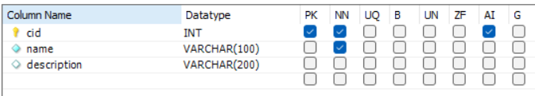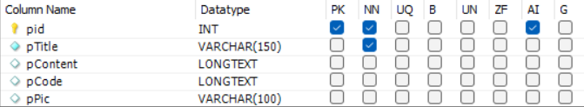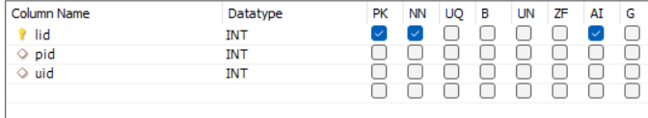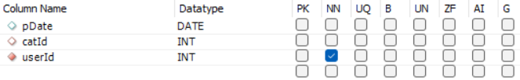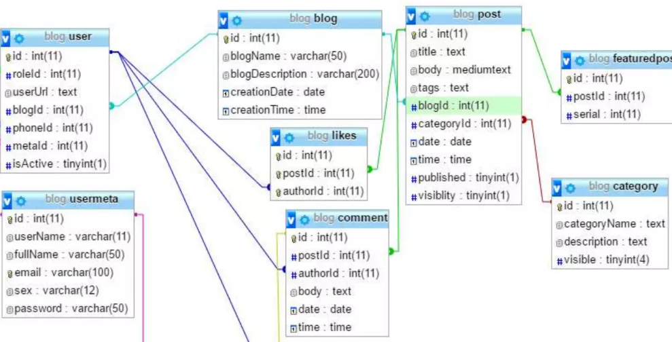

**User Authentication and Authorization:**

Design a user authentication system that securely manages user credentials and sessions.

Implement authorization rules to control access to various features and content.

Use Java Web Tokens (JWT) or similar technologies for secure session management.

**Content Management System (CMS):**

Create a user-friendly CMS for bloggers to create and manage their collage blog posts.

Allow bloggers to upload images and multimedia content, categorize posts, and edit their content easily.

**User Interactions and Social Features:**

Design the user interaction features, such as liking, sharing, commenting, and following other users.

Implement algorithms for user recommendations and content discovery.

**Front-End Design with JSP:**

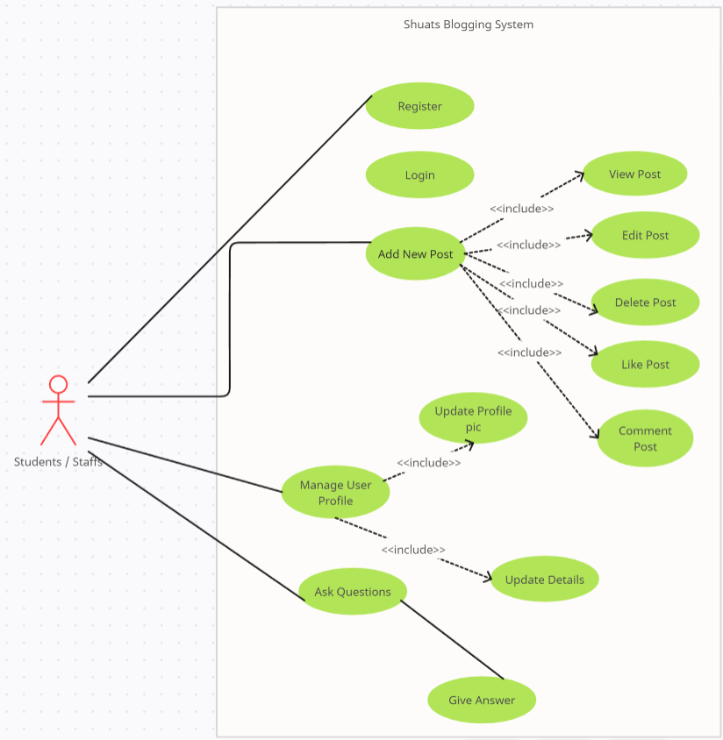

Design the layout and templates for your website using JSP.

Define JSP pages for rendering dynamic content, including user profiles and blog posts.

Use JSP tags and expressions to embed Java code within HTML for dynamic content generation.

**Search and Navigation:**

Implement search functionality that allows users to find relevant content.

Create filters and categories to help users explore different topics and interests.

Design user-friendly navigation menus and content recommendations.

**Security Measures:**

Plan for security measures to protect against common web application vulnerabilities, such as SQL injection and cross-site scripting (XSS).

Implement data encryption for sensitive information, like passwords and user data.

Utilize HTTPS for secure data transmission.

**Performance Optimization:**

Optimize website performance for fast loading times by optimizing database queries, using content caching, and minimizing server load.

Implement content delivery networks (CDNs) for efficient content distribution.

**Scalability:**

Plan for scalability by choosing scalable hosting solutions and designing components to handle increasing traffic and data volume.

By following a well-structured system design, you'll have a clear roadmap to guide the development of your collage blogging website, ensuring that it meets the specified requirements and functions effectively and securely. Collaborate with a skilled development team to implement this design effectively.

**IMPLEMENTATION AND TESTING**

The implementation and testing phases are critical steps in the development of your collage blogging website. During implementation, the actual code and components are built, while testing ensures that the application functions as expected, meets the specified requirements, and is free from critical issues. Here's an overview of these two phases:

*Implementation:*

**Development Environment Setup:**

Set up development environments for both server-side (Java) and client-side (HTML, CSS, JavaScript) components.

Install necessary development tools, databases, and web servers.

**Front-End Development:**

Begin front-end development using JSP, HTML, CSS, and JavaScript.

Create templates and layout designs for the website.

Implement dynamic content rendering using JSP for user profiles, blog posts, and other features.

**Back-End Development:**

Develop the server-side components using Java, including user authentication, content management, and interaction features.

Implement data handling and processing logic, connecting to the MySQL database.

Ensure that the code follows best practices and coding standards.

**Database Implementation:**

Create the MySQL database tables and relationships based on the database design from the system design phase.

Implement stored procedures, triggers, and indexes for efficient data retrieval and storage.

Populate the database with sample data for testing.

**User Authentication and Authorization:**

Build the user authentication system with features like registration, login, password reset, and email verification.

Implement user authorization rules to control access to different parts of the application.

**Content Management System (CMS):**

Develop a user-friendly CMS for bloggers to create, edit, and manage their collage blog posts.

Enable features for image and multimedia content uploads, post categorization, and editing.

*Testing :*

**Unit Testing:**

Developers conduct unit tests to check the individual components and functions for correctness and functionality.

**Integration Testing:**

Verify that the different parts of the application work together as expected.

Test how components interact with each other and the database.

**Security Testing:**

Perform security testing, including vulnerability scans and penetration testing.

Ensure the website is resistant to common security threats.

**Performance Testing:**

Conduct performance tests to measure the website's speed and responsiveness.

Identify and resolve performance bottlenecks.

**Accessibility Testing:**

Ensure that the website is accessible to users with disabilities, adhering to accessibility standards (e.g., WCAG).

Once the implementation and testing phases are completed successfully, you can proceed to deployment, where the website is made available to users. It's crucial to conduct thorough testing to identify and resolve any issues before the website goes live. Additionally, consider beta testing with a limited group of users to gather feedback and make improvements based on real-world usage.

**CONCLUSION AND FUTURE SCOPE**

*Conclusion:*

The development of your collage blogging website represents a significant achievement, offering a creative platform for users to express themselves and engage with diverse and visually captivating content. Throughout the project, you've successfully designed, implemented, and tested a dynamic web application that fulfills the initial requirements. Here are some key points to conclude:

**User-Centric Experience:**Your website provides a user-centric experience, enabling bloggers to share their passions through collage-style content and fostering a vibrant community.

**Robust Functionality**:The site includes robust features for user registration, content creation and management, social interaction, and content discovery.

**Security and Compliance:**Security measures have been implemented to protect user data and ensure compliance with data protection regulations and copyright laws.

**Performance Optimization:**The website is optimized for performance, with quick loading times and efficient content delivery.

**Responsive Design:** The responsive design ensures that users can access the site seamlessly from various devices and screen sizes.

**Comprehensive Testing:**Rigorous testing has been conducted, covering unit testing, integration testing, user acceptance testing, security testing, performance testing, and more to ensure reliability.

***Future Scope :***

As you move forward, there are several potential areas for future development and improvement to enhance your collage blogging website:

**Mobile Applications:** Consider developing mobile apps for iOS and Android platforms, extending the reach of your platform to a broader audience.

**Enhanced Interactivity:** Implement more advanced features, such as real-time collaboration on collages, live-streaming, and augmented reality (AR) integration for immersive experiences.

**Machine Learning and Personalization:** Implement machine learning algorithms to provide personalized content recommendations and enhance the user experience.

**Content Moderation:** Enhance content moderation and user reporting tools to maintain a safe and welcoming environment for all users.

**User Feedback:** Actively solicit and implement user feedback to ensure that the website evolves to meet the changing needs and preferences of your community.

By addressing these future scope areas and staying attuned to emerging technologies and trends, your collage blogging website can continue to grow, adapt, and remain a vibrant and engaging platform for creative expression and community interaction. Remember that success in the digital landscape often involves ongoing innovation and adaptation to meet the dynamic demands of your user base.

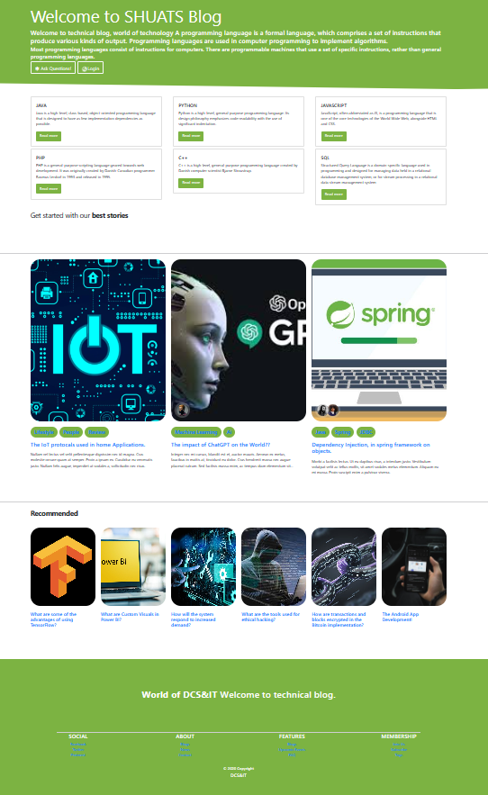 **Screen Shots of the Web-Site**

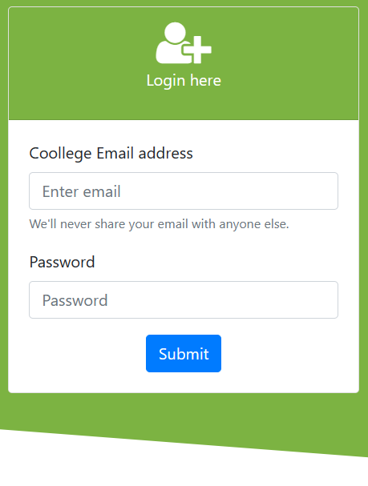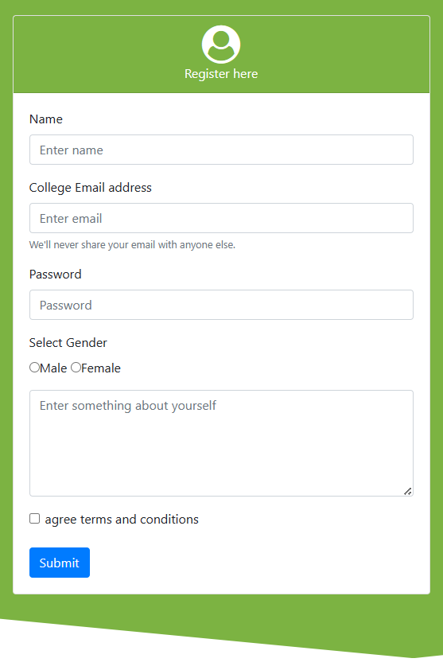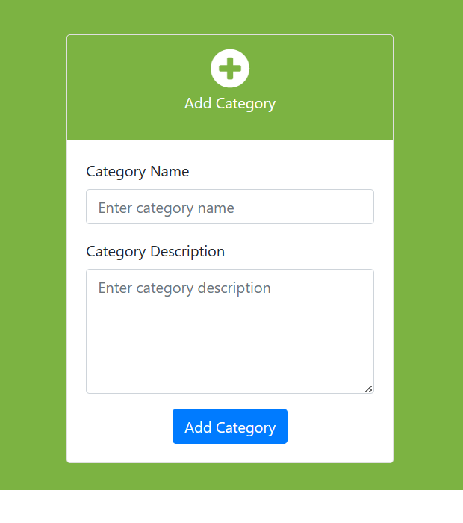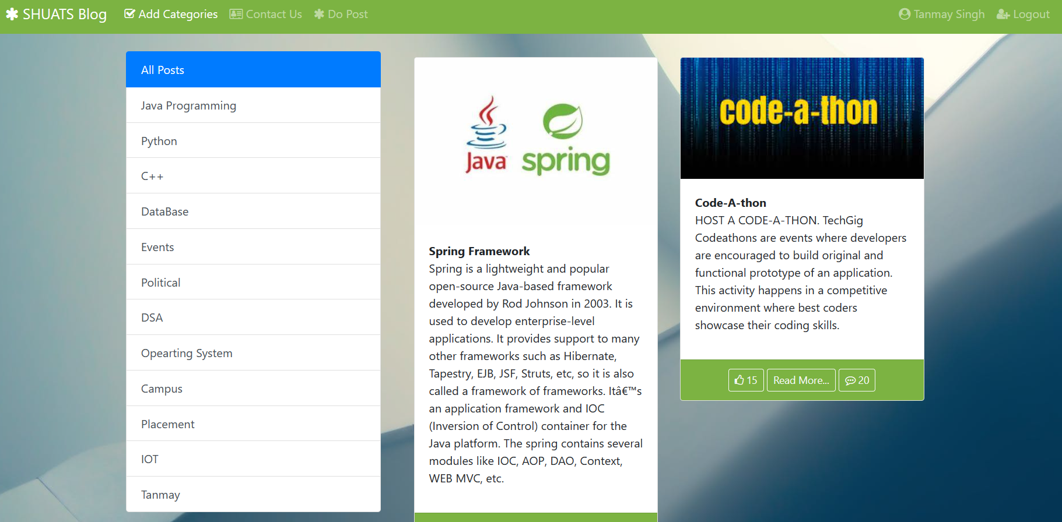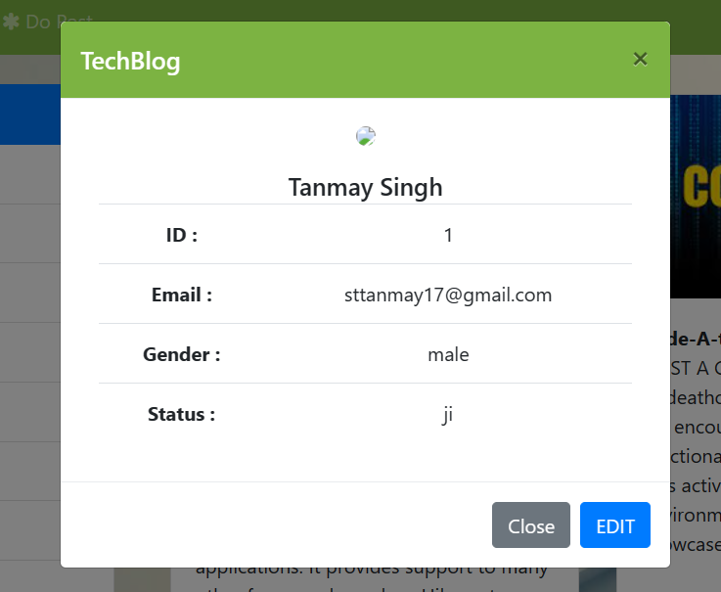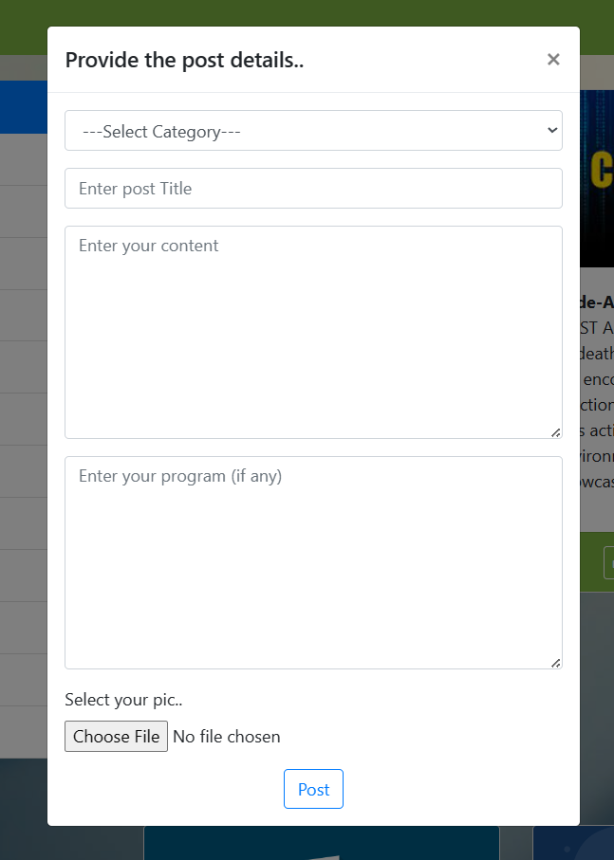

**REFERENCES**

1. **W3Schools:** (<https://www.w3schools.com/>) - An online resource for learning web development technologies like HTML, CSS, and JavaScript.
2. **MySQLDocumentat**ion:(<https://dev.mysql.com/doc/>) - Official documentation for MySQL, covering a wide range of topics and scenarios.
3. **OWASP Top Ten:** (<https://owasp.org/www-project-top-ten/>) - The Open Web Application Security Project's top ten list of web application security risks.
4. **SeleniumWebDriverDocumentation:**<https://www.selenium.dev/documentation/en/webdriver/> - Official documentation for Selenium, a widely used tool for web application testing.
5. **JavaServlets**: (“https://github.com/LearnCodeWithDurgesh/TechBlog”)